Lab – 4

1) Creating the developer account:

i) We first create a developer account on Salesforce by visiting: [*https://developer.salesforce.com/signup*](https://developer.salesforce.com/signup)and entering the relevant details as follows.

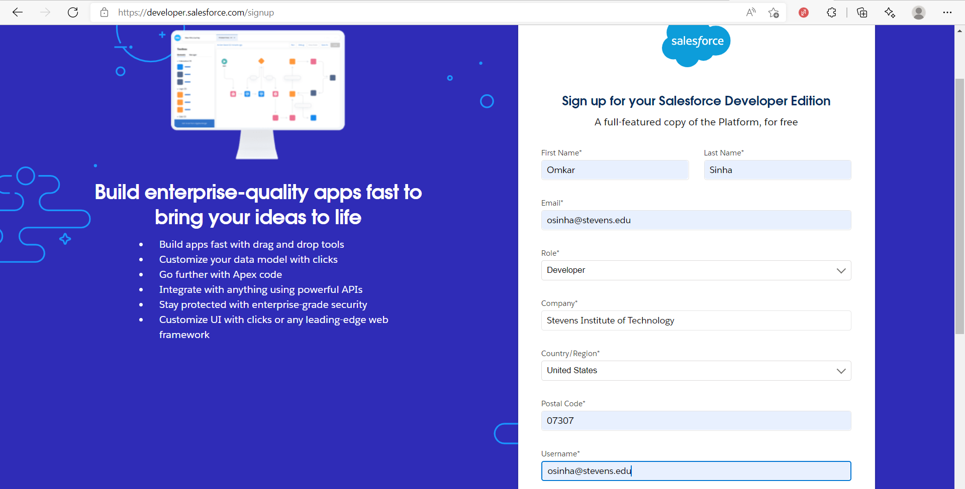

ii) We submit the details

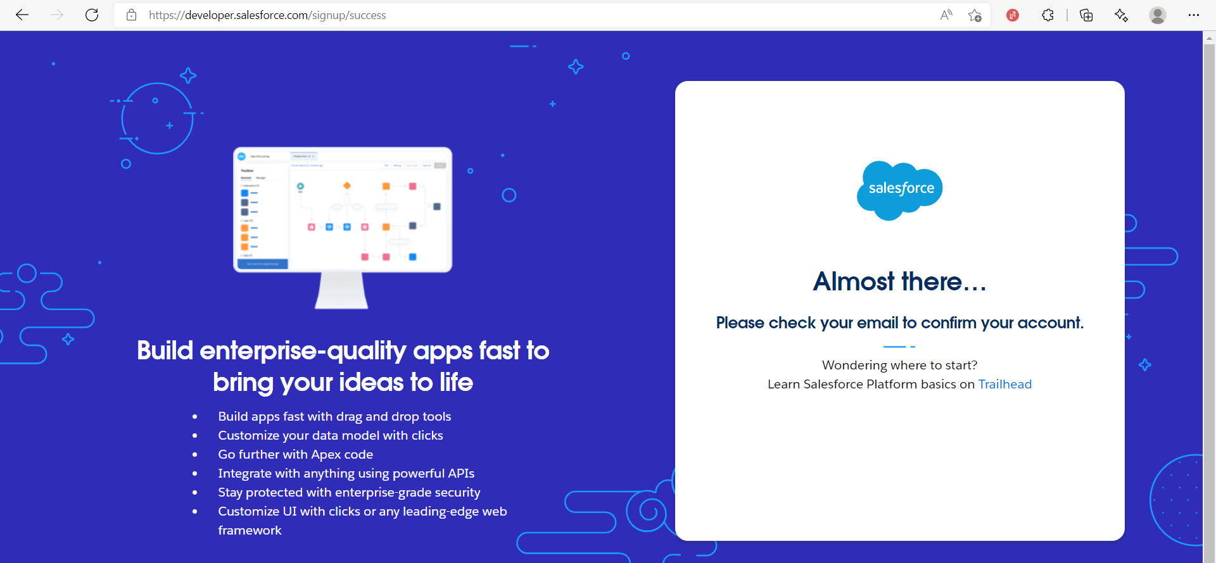

iii) We receive a verification mail, as follows:

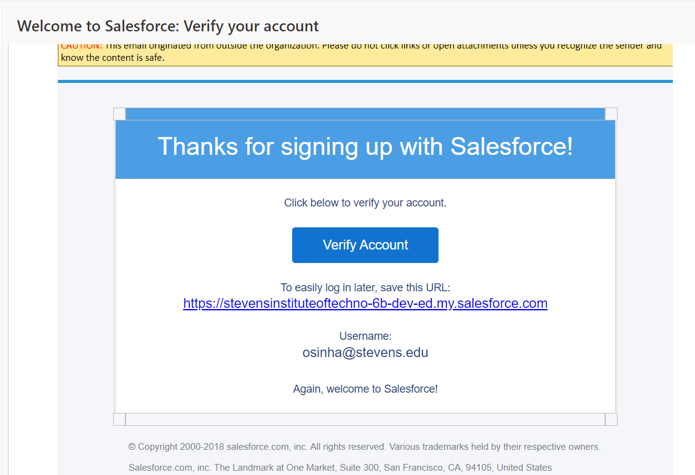

iv) We click on “Verify Account”. Then, we enter our passwords and security question and select “Change Password” as follows:

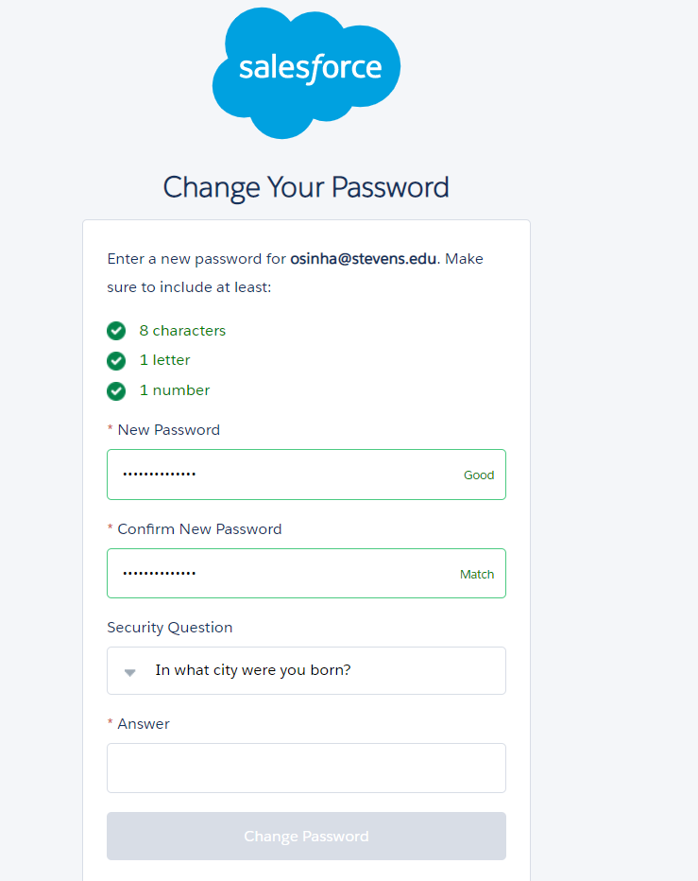

v) Now, the Salesforce Lightning Page gets loaded:

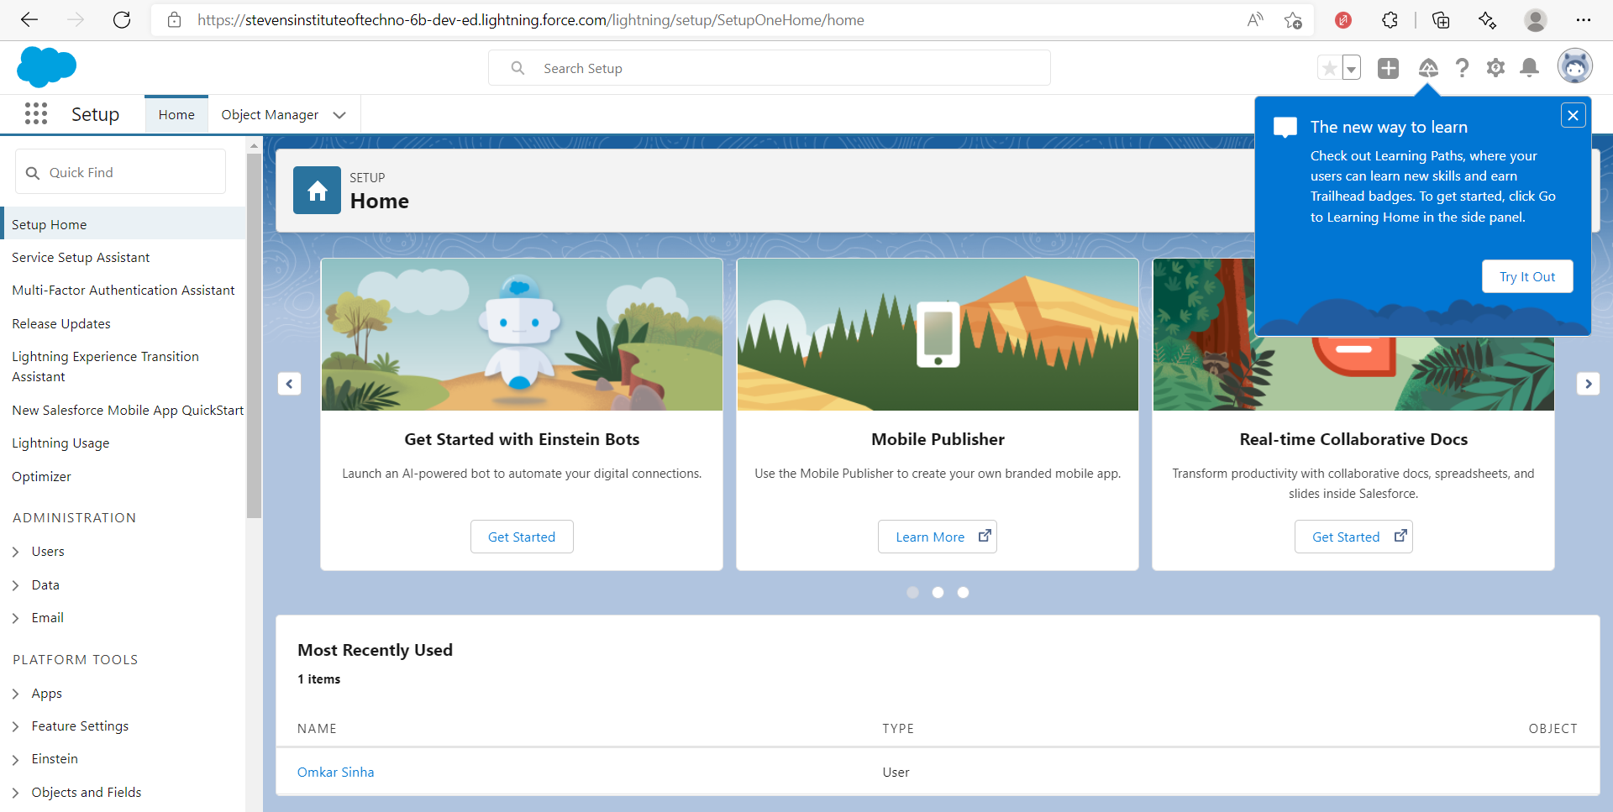

vi) We switch to “Salesforce Classic”, from the lightning page as follows:

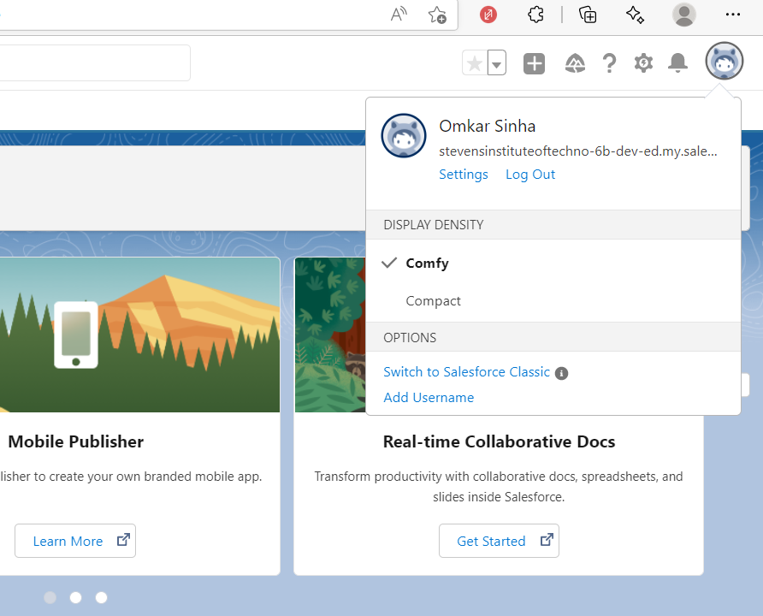

vii) We successfully switch to Salesforce Classic as Follows:

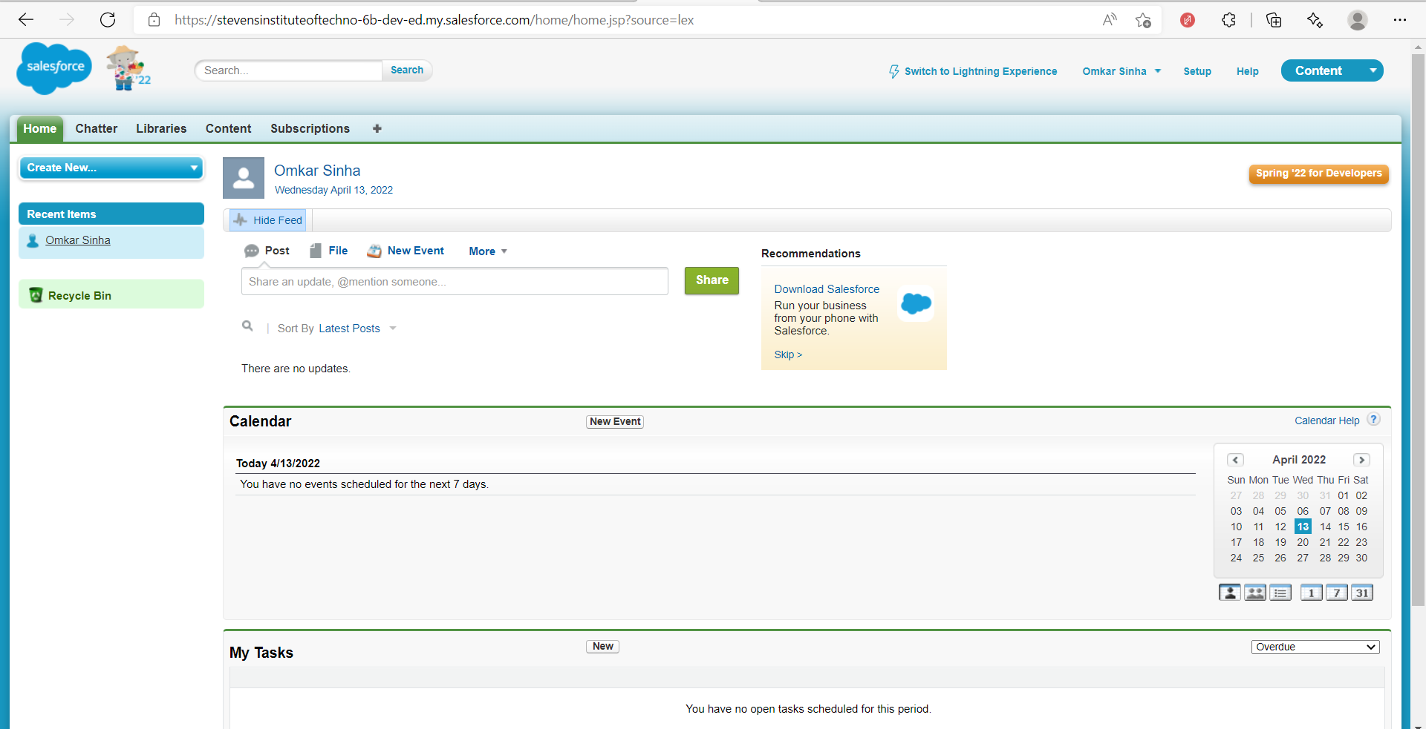

2) Creating record using Salesforce Standard Object (Account):

i) From above screen, we choose “+” in the right side of top panel. We get following:

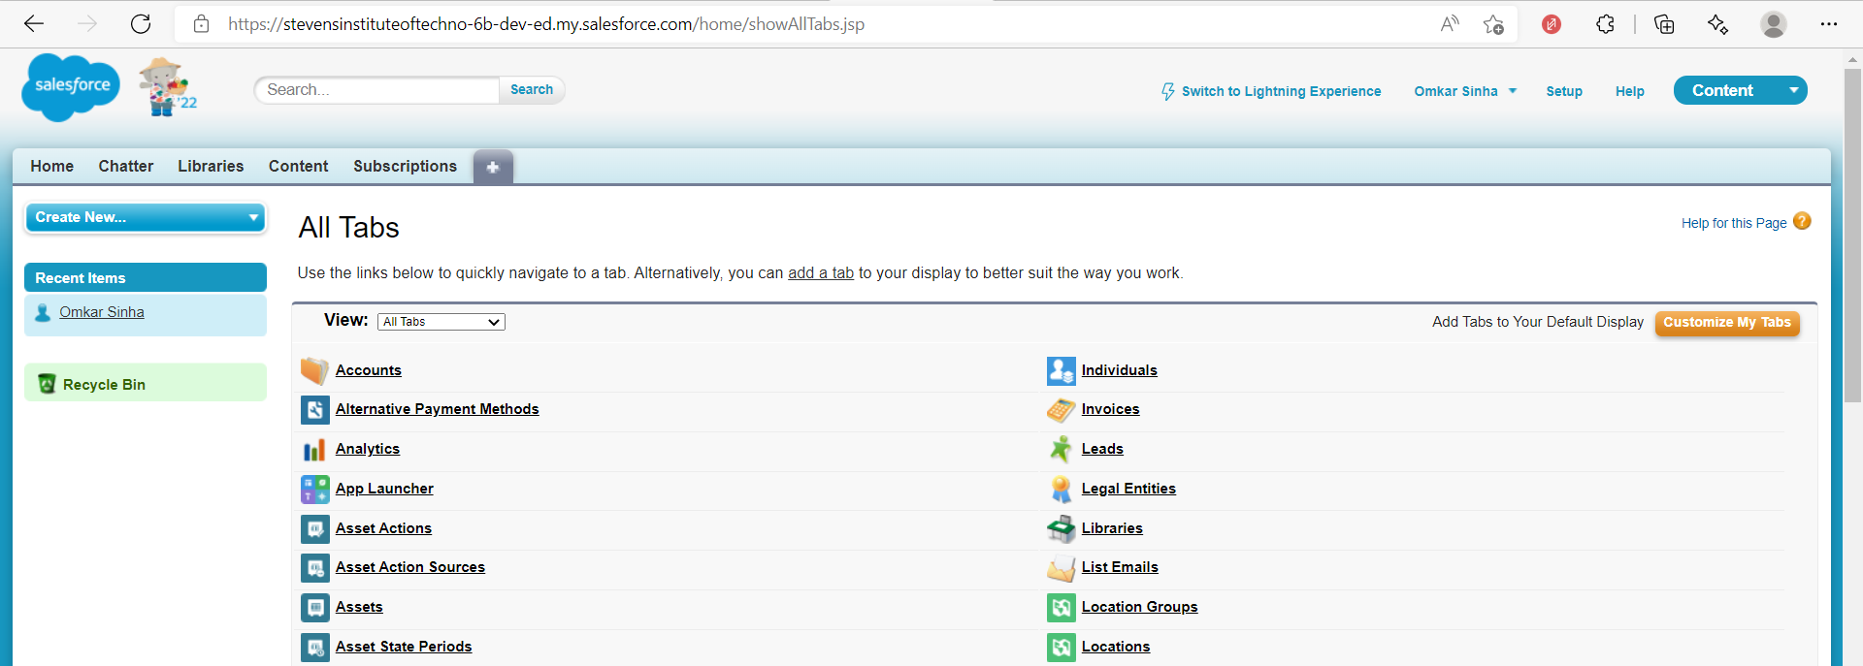

ii) We select “Accounts” from above list, since we are going to create a record for the standard(predefined) Account object. We get as follows:

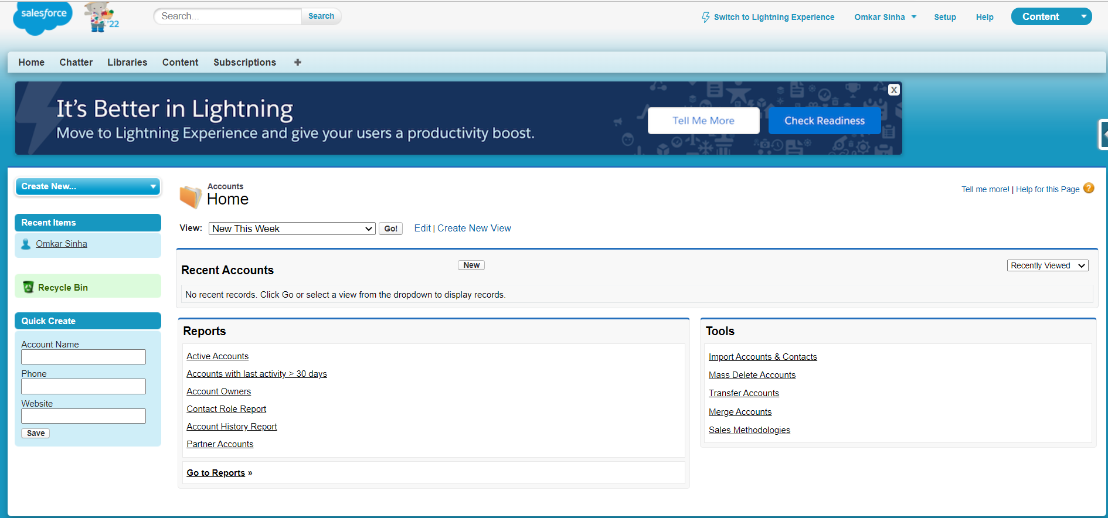

iii) We select “New” from above screen to create a new record. We fill out the details as follows:

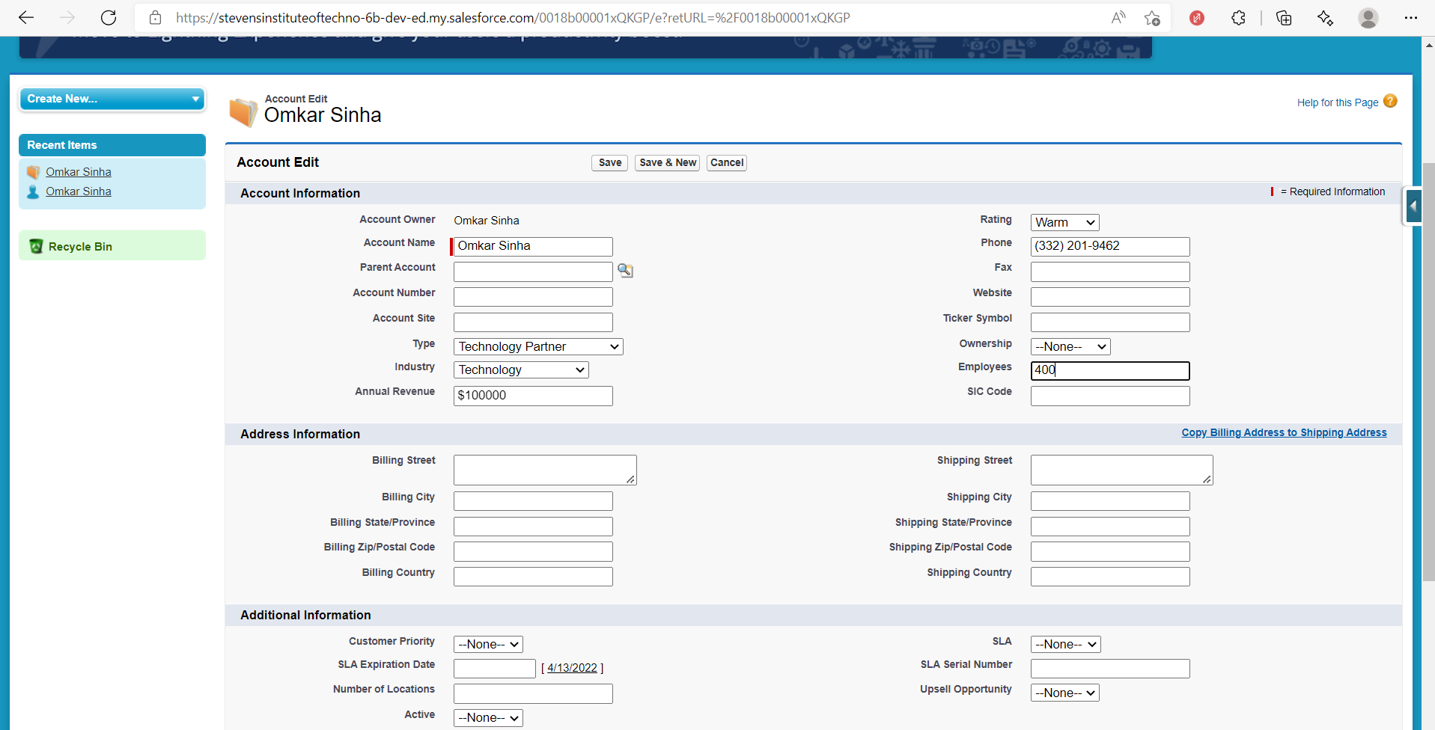

iv) We select “Save”, and a new record of “Accounts” object is created as follows:

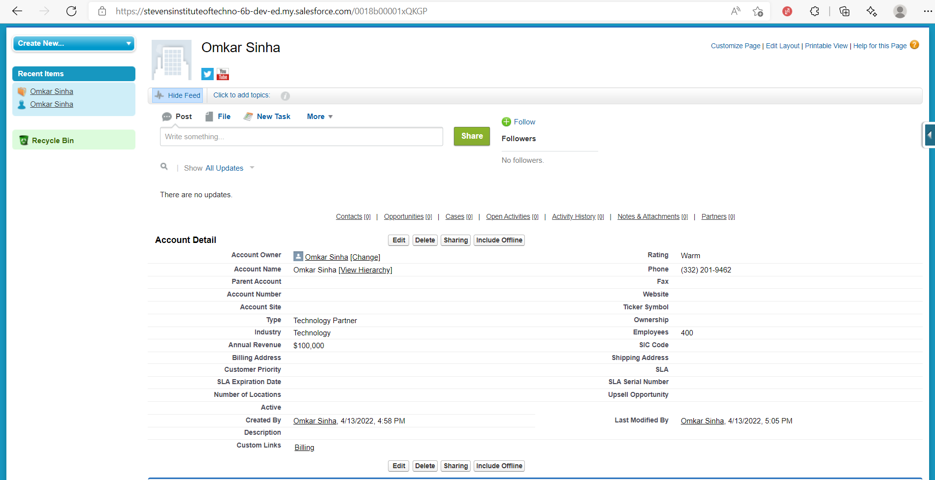

3) Creating Custom Objects and Fields:

A) Creating Custom Object:

i) We select “Setup” from the top right panel:

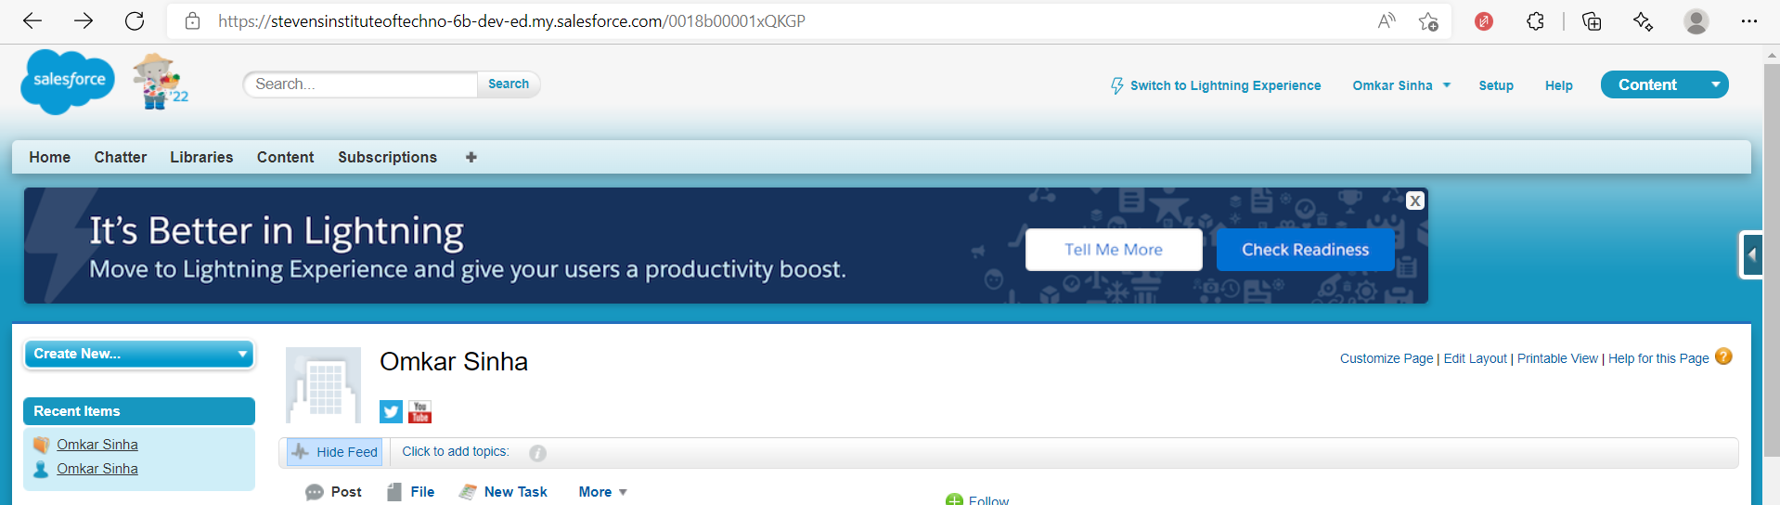

ii) In the search bar on left side, we search for ”Objects” and select create object:

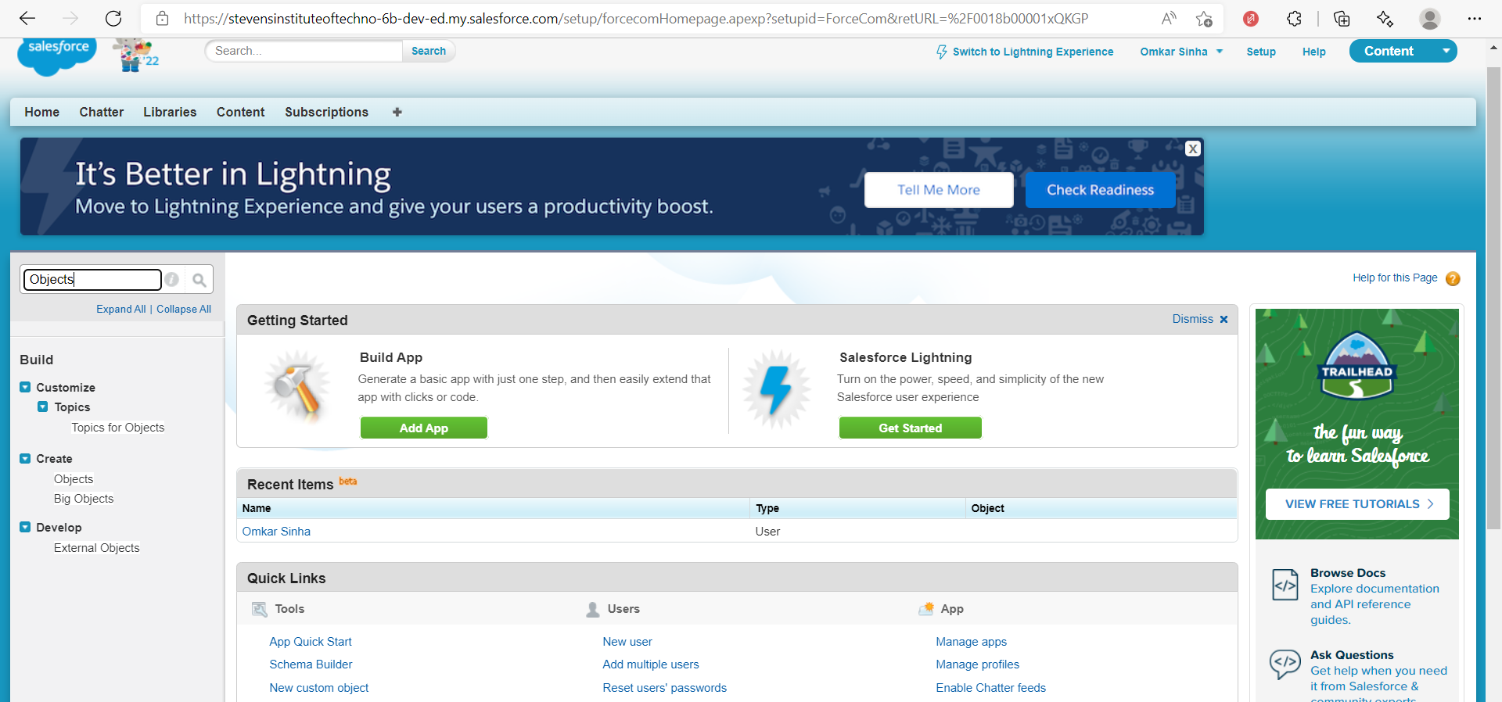

iii) We get below screen. We select “New custom object”:

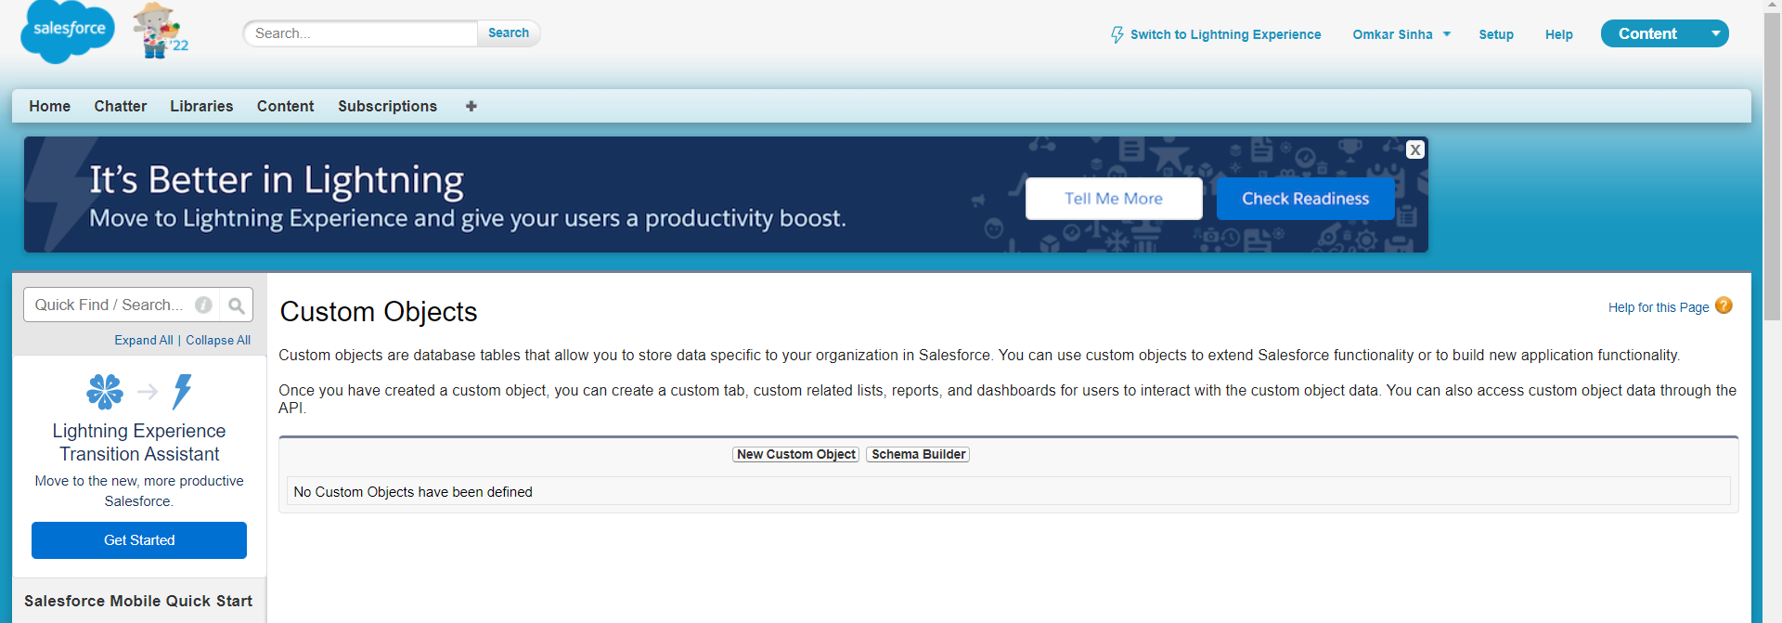

iv) We feel out the details for the custom object we’re creating and save it, as follows:

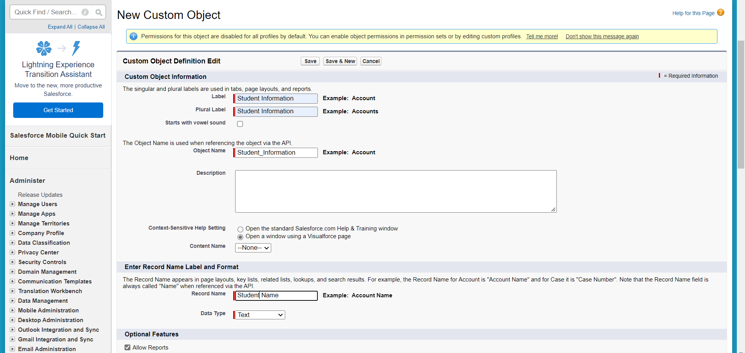

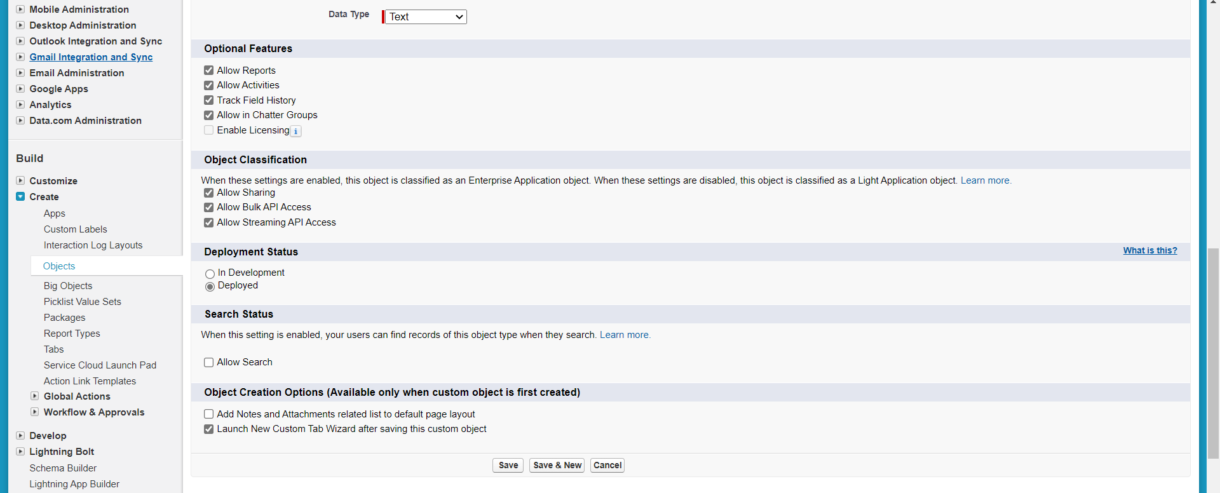

v) From “New Custom Object tab”, choose any tab style and select “Next”:

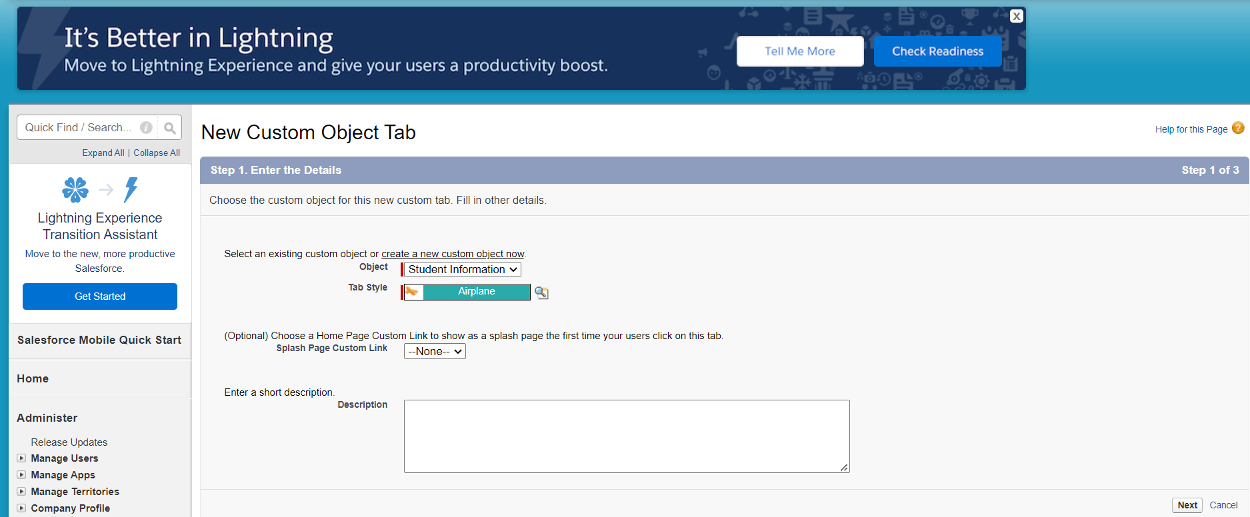

vi) Make sure “Apply one tab visibility to all profiles” is selected and select Next:

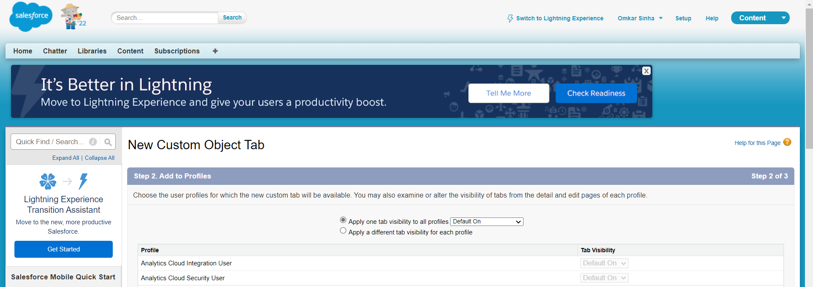

vii) Choose “Save”:

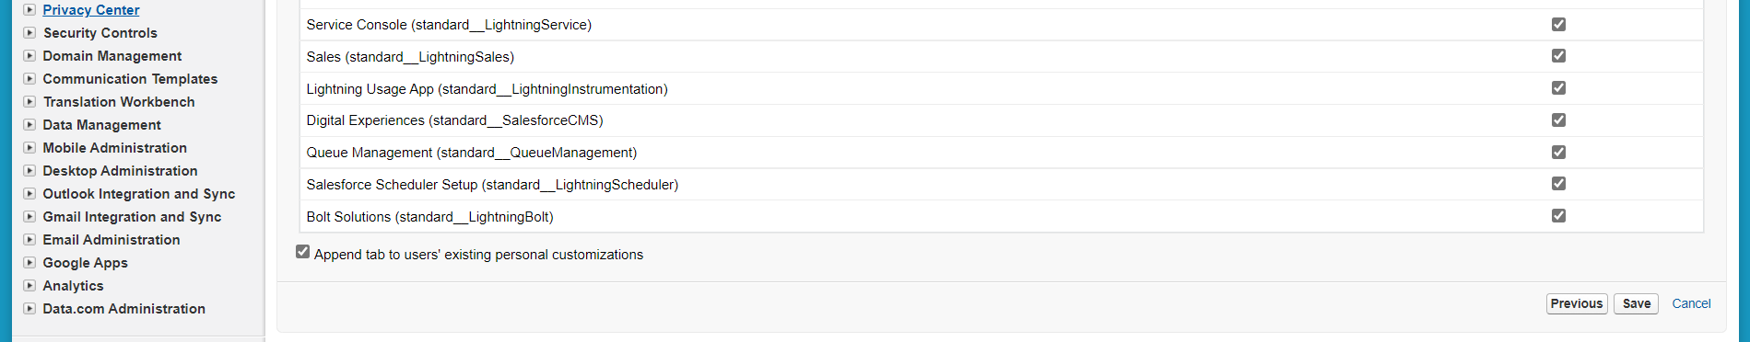

viii) We get the following. Our custom object “Student Information” is created and its details are given as follows.:-

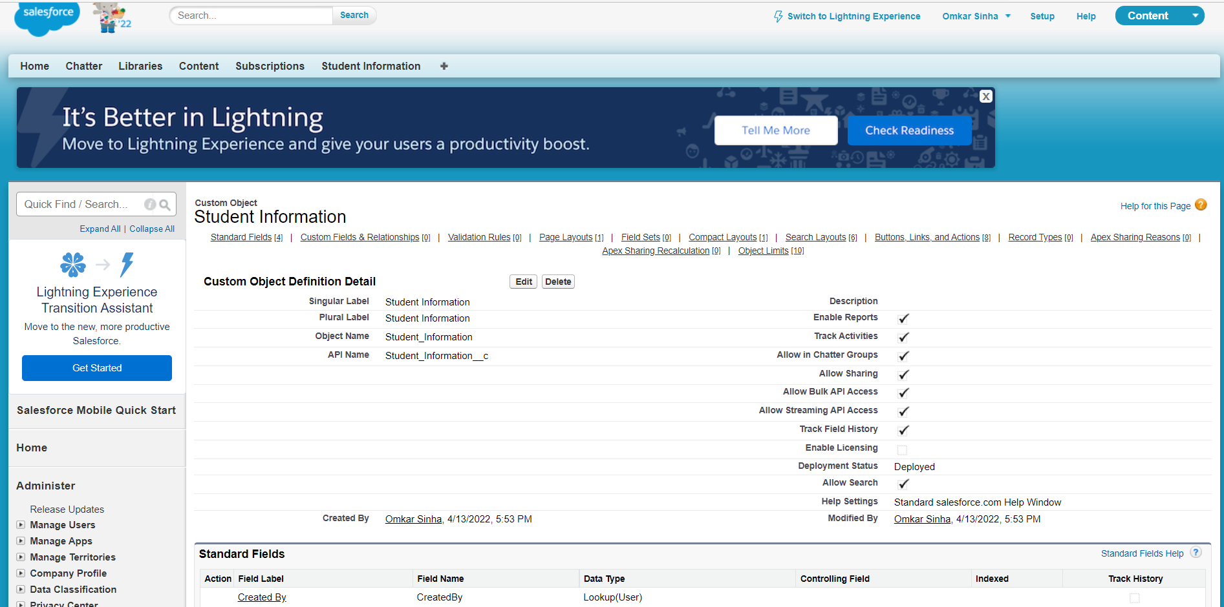

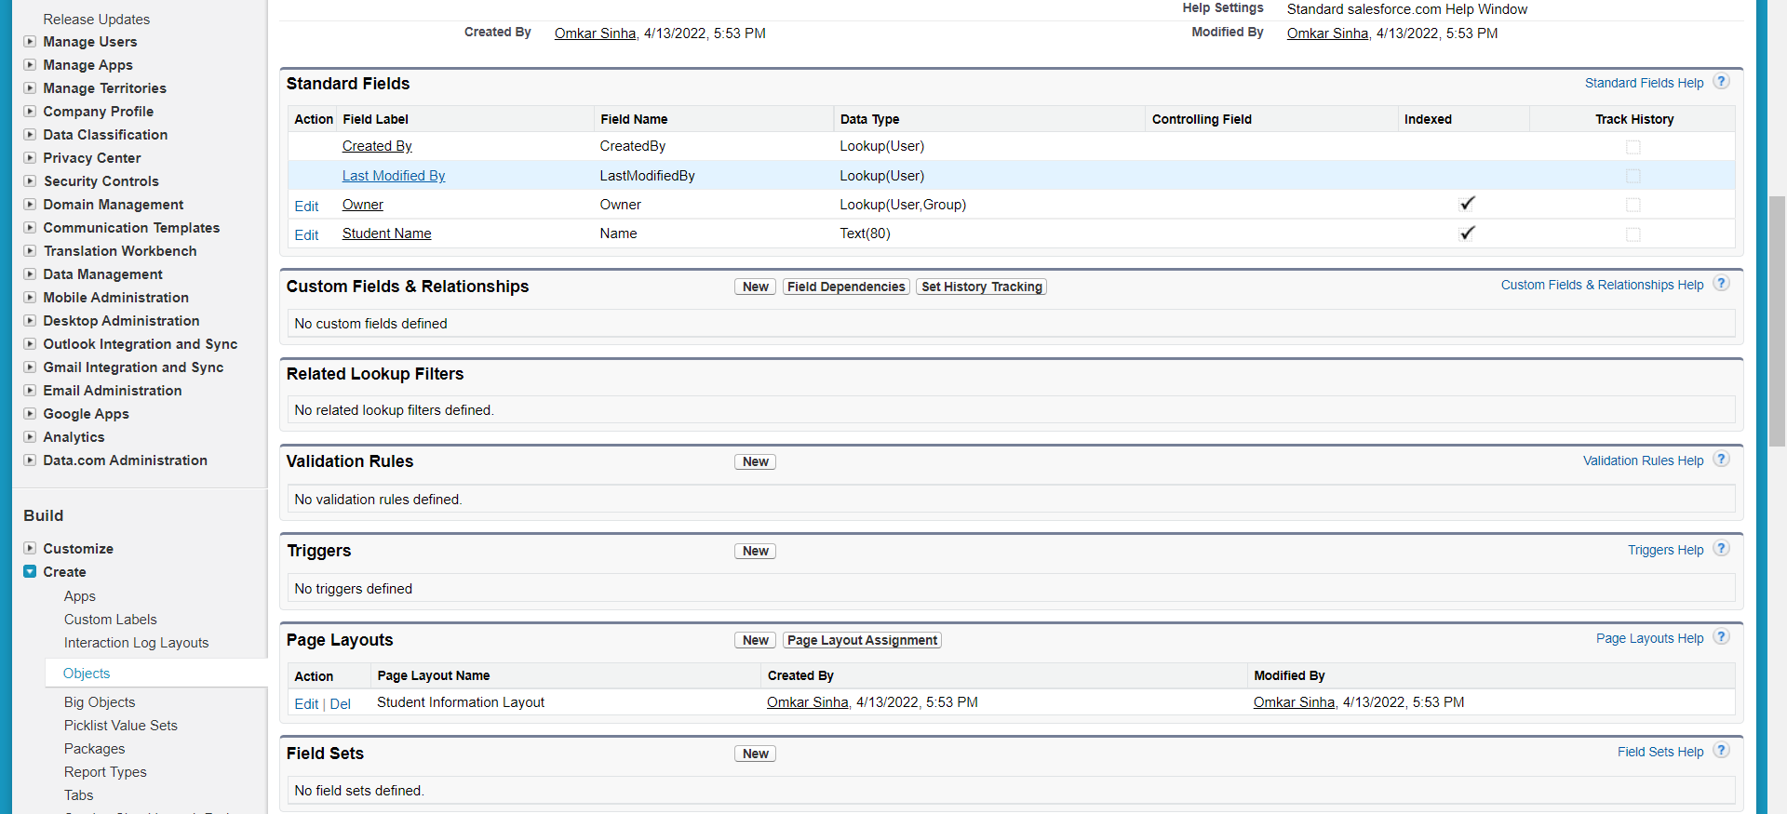

B) Creating Custom Fields

i) From “Custom Fields and Relationships” section, select “New” :

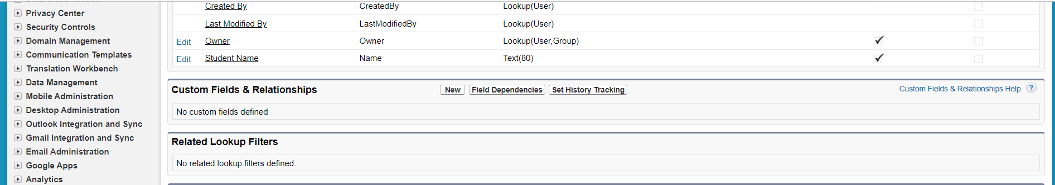

ii) We start entering the details our first custom field for our custom object “Student Information”. This field is the department field and data-type is Text-area(long), which we choose below :

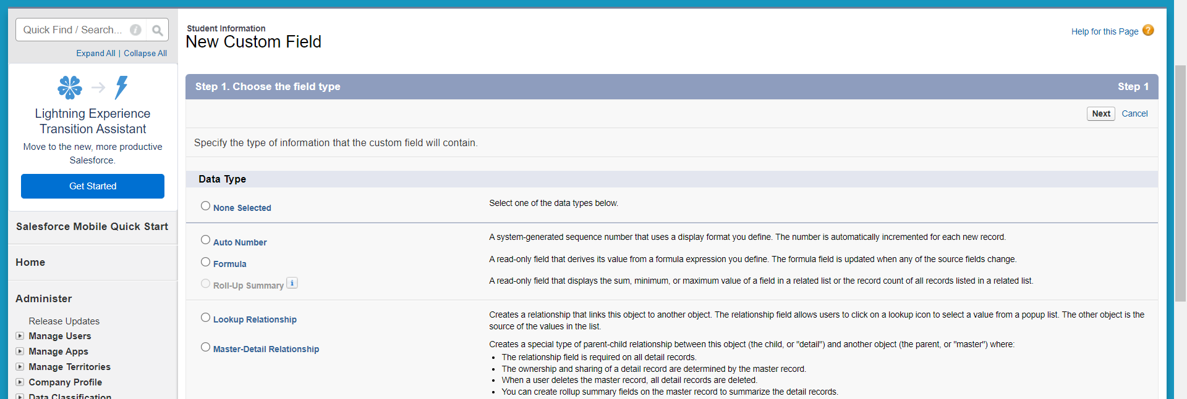

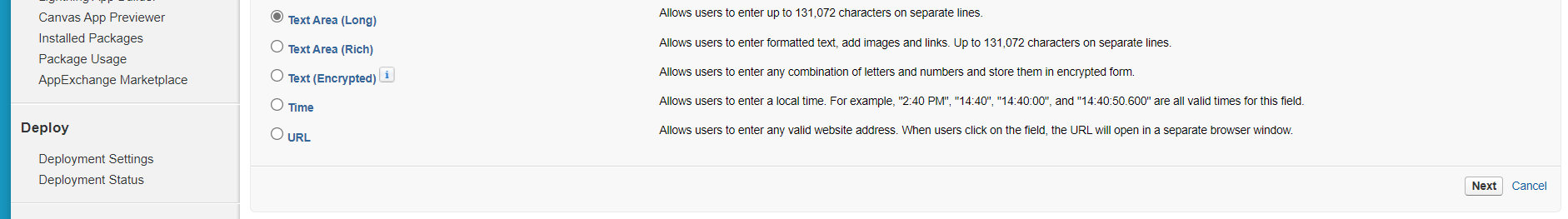

iii) We select Next, and enter field label(here “Depatment”) and field name is automatically populated. We select next:

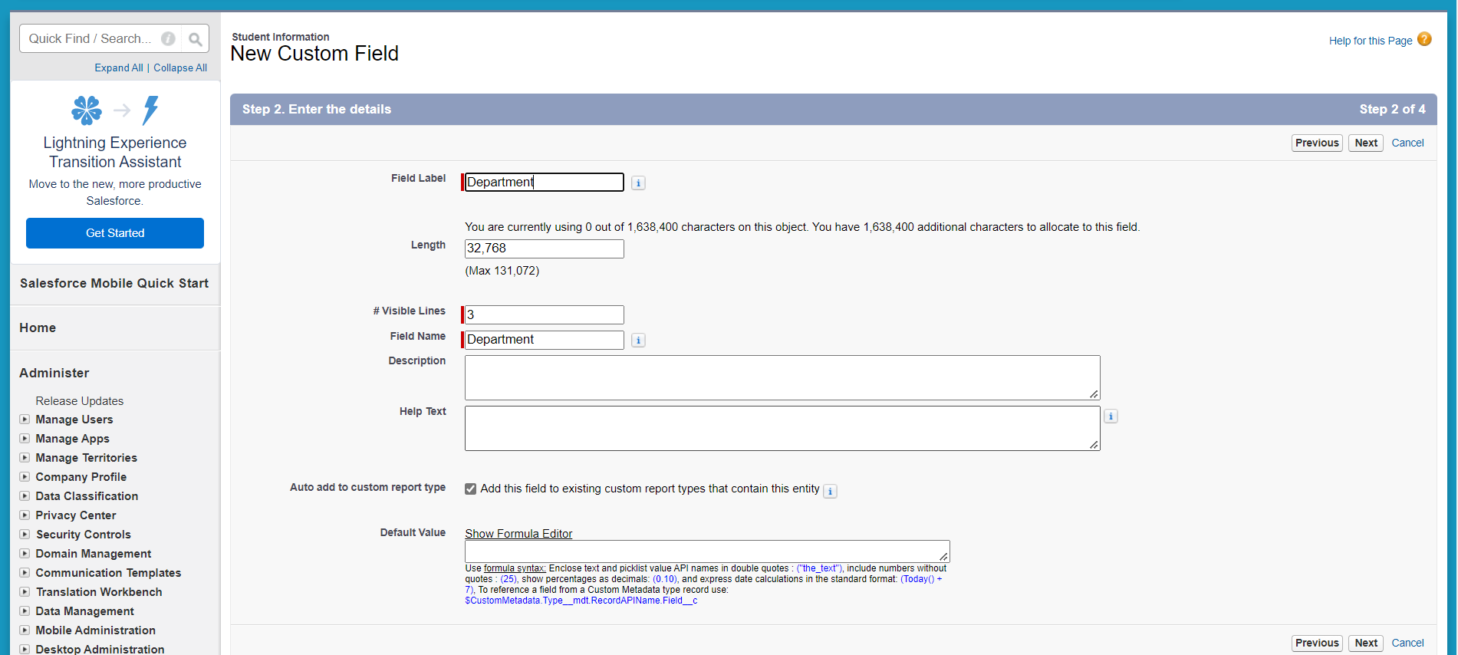

iv) We check Visible and go to next:

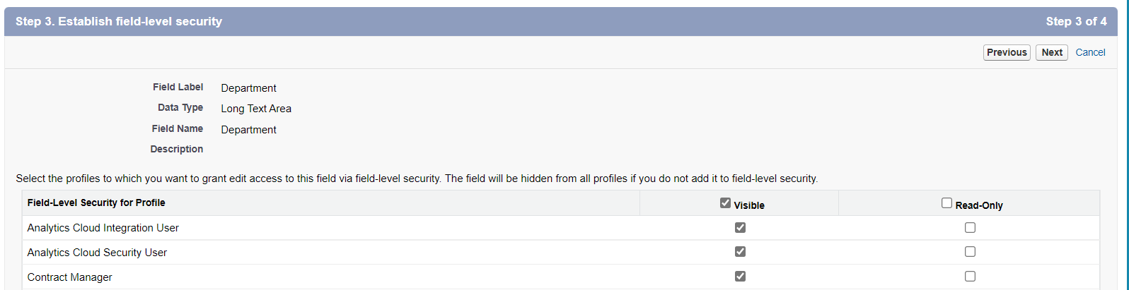

v) We add this field to Student Information page layout and then select “save and new”: (in order to create other fields)

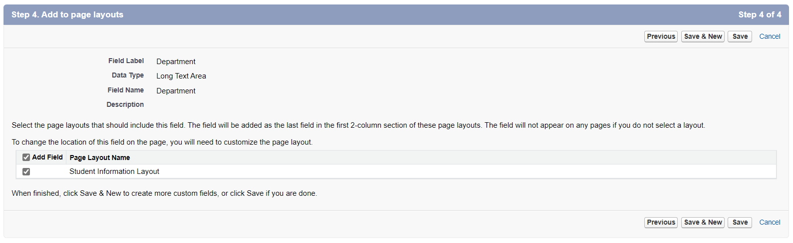

vi) We create 3 other fields in the same way. These fields are:

1) CWID:

Field Type: Text Area Long

Field Label: CWID

Field Name: CWID (This will be populated automatically)

Visible: Checked

Add to page layouts: Student Information Layout Checked

2) Semester

Field Type: Picklist (Don’t Select Picklist (Multi-Select)

Field Label: Semester

Values: Click on Enter values, with each value separated by a new line and enter following values - Fall, Spring, Summer (All these values need to be on separate line)

Field Name: Semester (This will be populated automatically)

Visible: Checked

Add to page layouts: Student Information Layout Checked

3) Date of Joining

Field Type: Date

Field Label: Date of Joining

Field Name: Date of Joining (This will be populated automatically)

Visible: Checked

Add to page layouts: Student Information Layout Checked

In case of the semester field, we specify picklist as datatype and enter the values as follows:

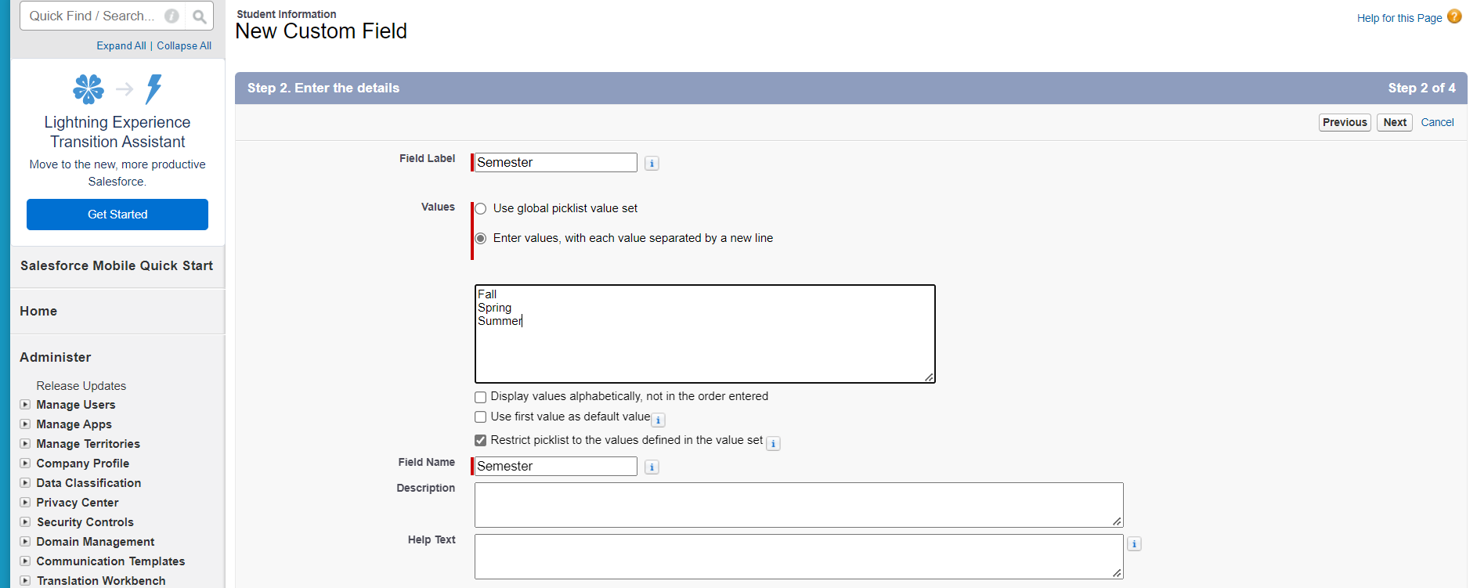

vii) Once we have saved the last field, we get the “Student Information” custom object details. We see the following custom fields as we created:

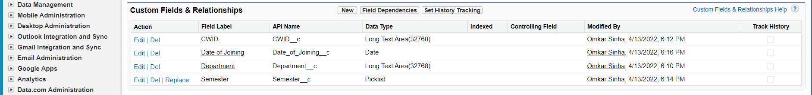

4) Creating record on Custom Object:

i) We select the “Student Information” Tab on the Top, and click on New:

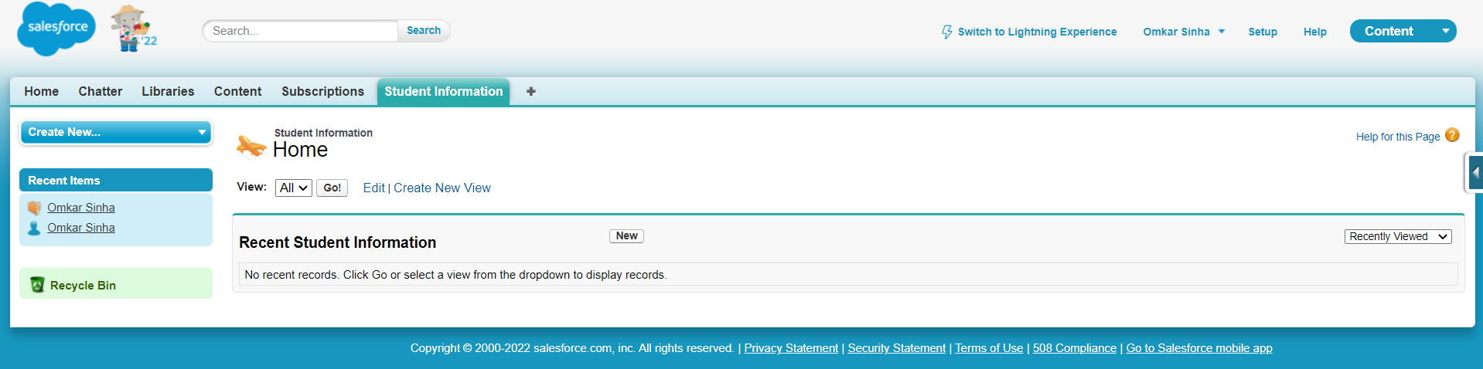

ii) Now we get to enter details for the record. We enter the details and select save:

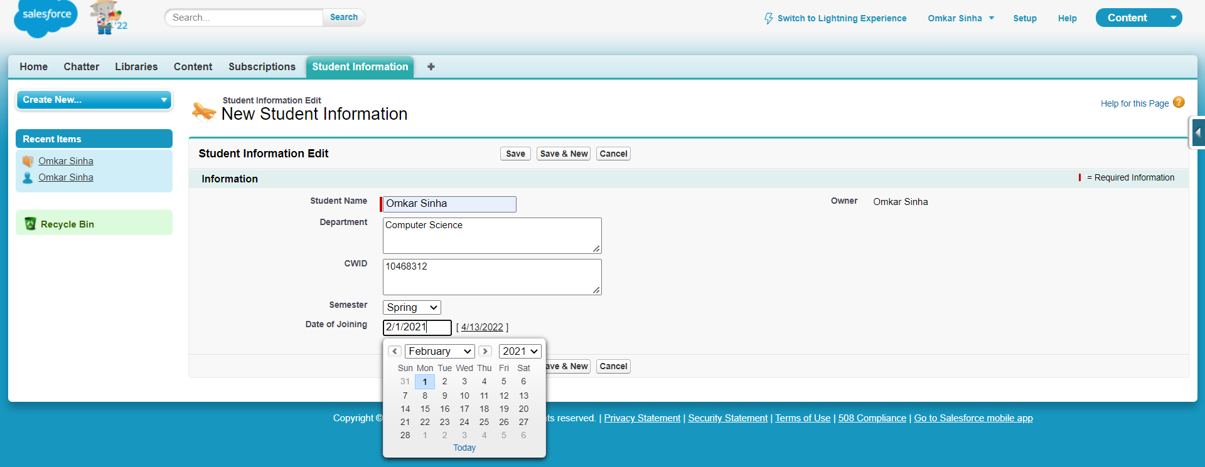

iii) We see the record details as follows:

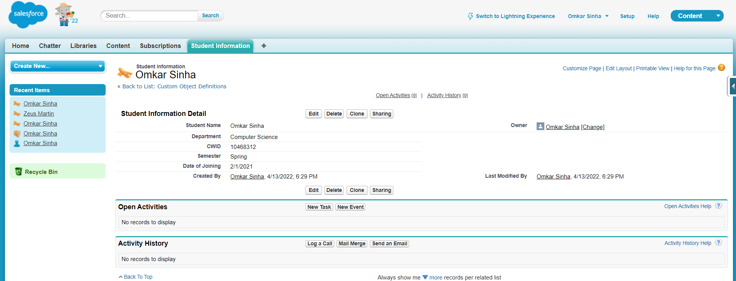

iv) We create another record, with following details:

Name: Zeus Martin

Department: Aeronautics

CWID: 12345678

Semester: Spring

Date of joining: 8/1/2021

Hence, we get 2 records as follows:

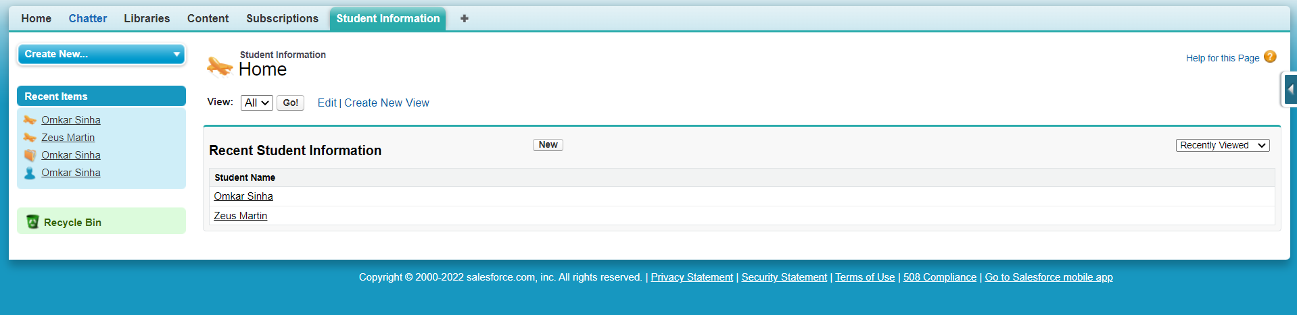

5) Retrieving the created records using SOQL

i) We click on user menu bearing name before setup, and select “Developer console” :

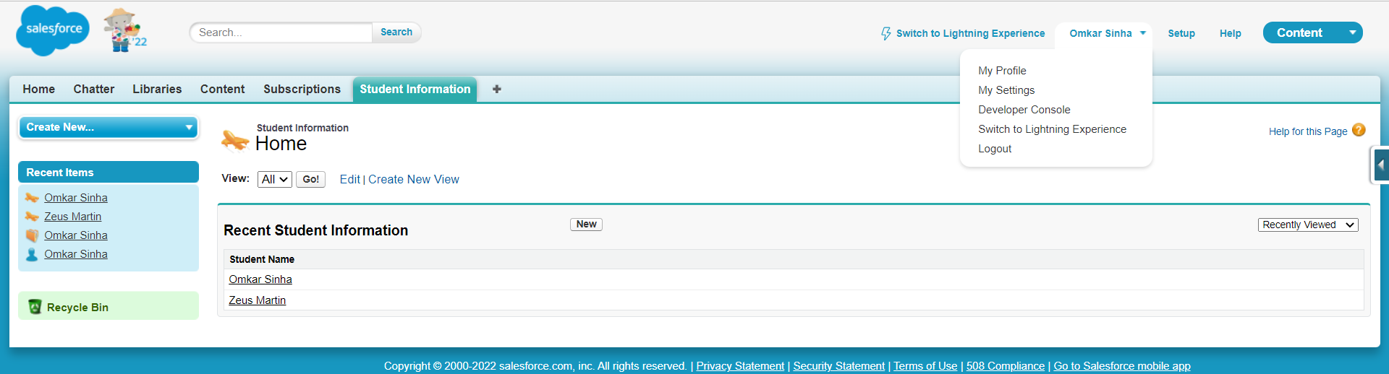

ii) On the console, we choose “query editor” from bottom panel.

1) For standard object that we populated with a record in Part 2, we enter query as follows and select Execute:

*SELECT Id, Name FROM Account WHERE Name = 'Omkar Sinha'*

We get following output:

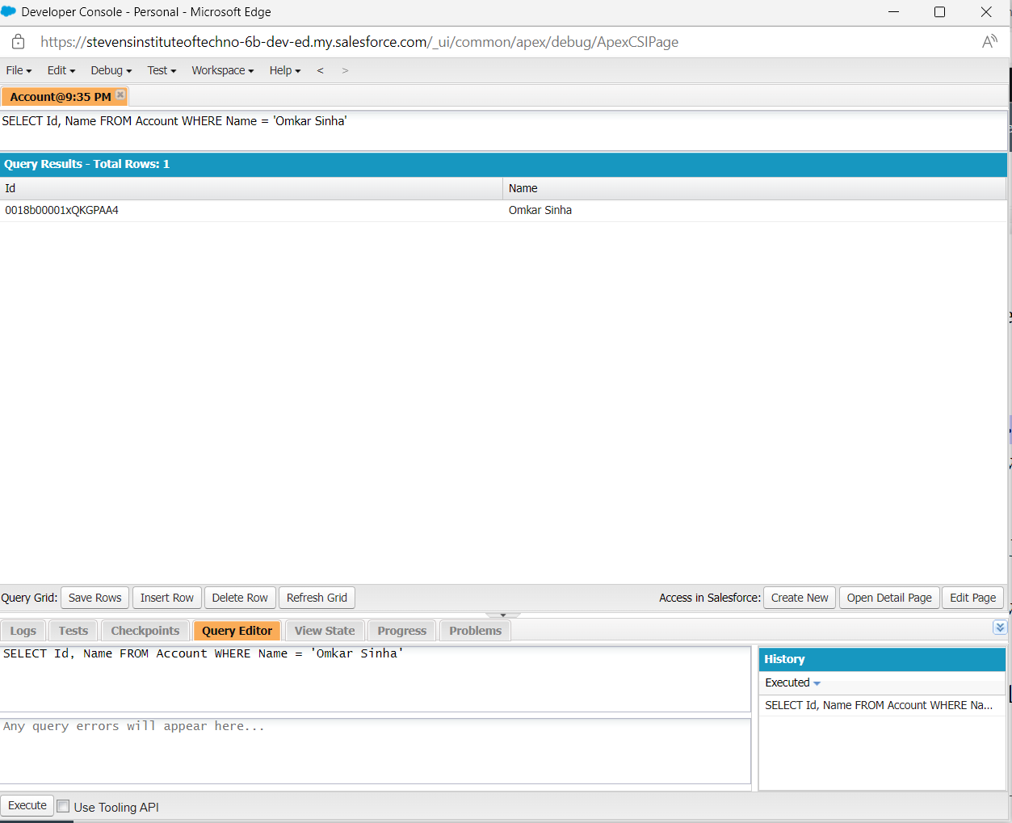

2) For custom object that we created in Part 3 and populated with records in Part 4, we enter query as follows and select Execute:

*SELECT Id, Name FROM Student_Information__c WHERE Name = 'Zeus Martin'*

We get following output:

